The update procedure through OTA – Allview
P5 Energy / Android 5.1 / 01.03.2016 / V5436 to V5786

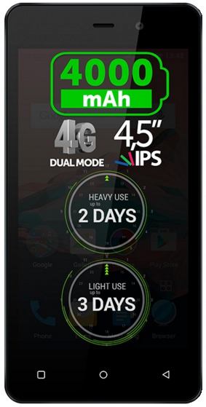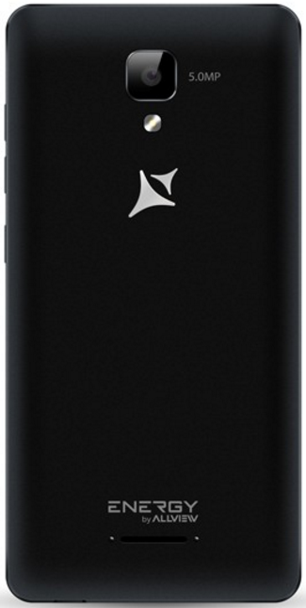
The software update advantages are:
- software stability improvement;
- translations improvement;
- fixing some minor bugs.

ATTENTION! The phone must be fully charged when initializing the procedure.
ATTENTION! Please do not stop under any circumstance the update operation.
The software update is an operation which is realised on own responsibility by following the steps below.
To update the software version of the Allview P5 Energy smartphone it is necessary to follow the next steps:

- Turn on the phone and connect it to a wireless network.
- Open the ”System updates” app from the apps menu:

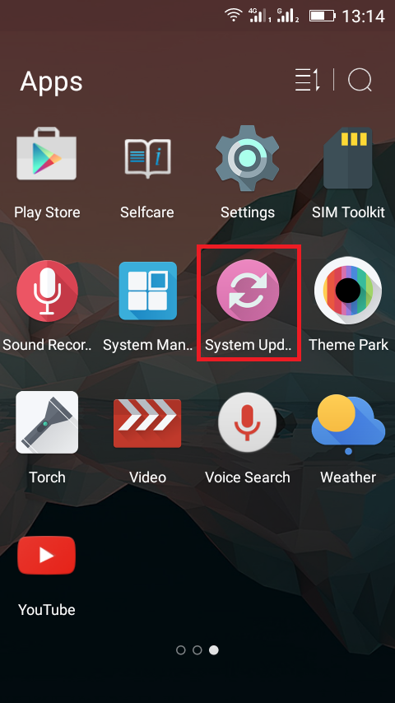
- For search software version use button “Check new version”

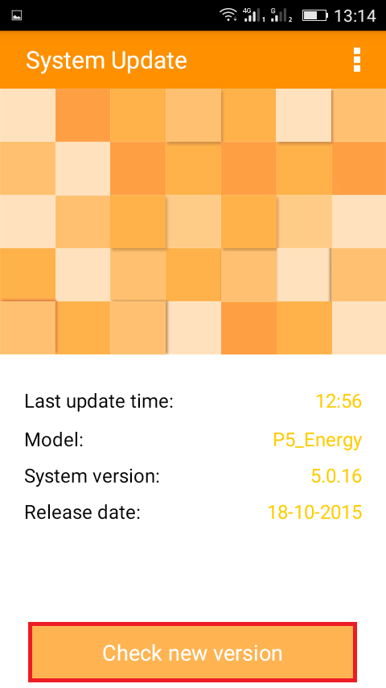
- The “System Update” app has detected a new software version (P5_Energy_0205_V5786). Tick the option: Download:

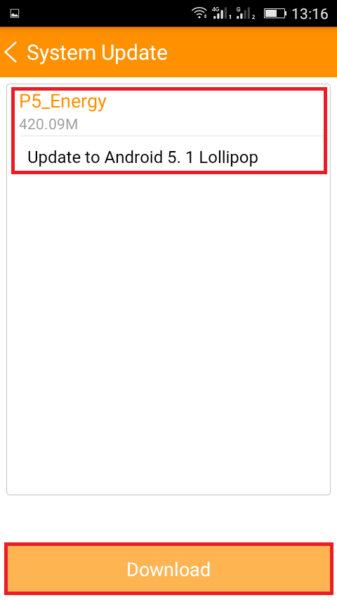
- Please wait for the full software download in the phone's internal storage/micro SD card.

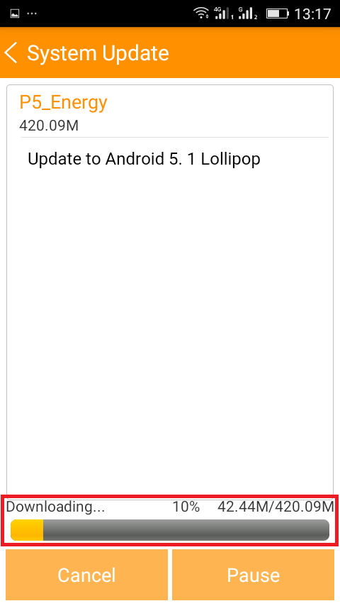
- After full software download, select “Upgrade”:

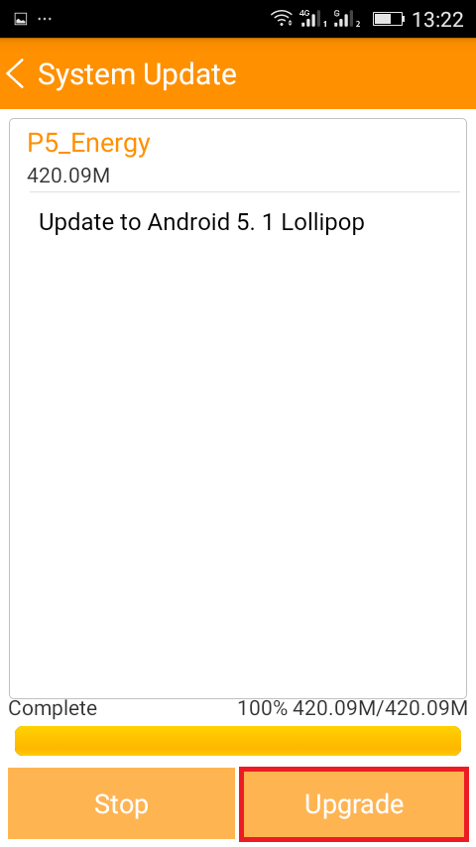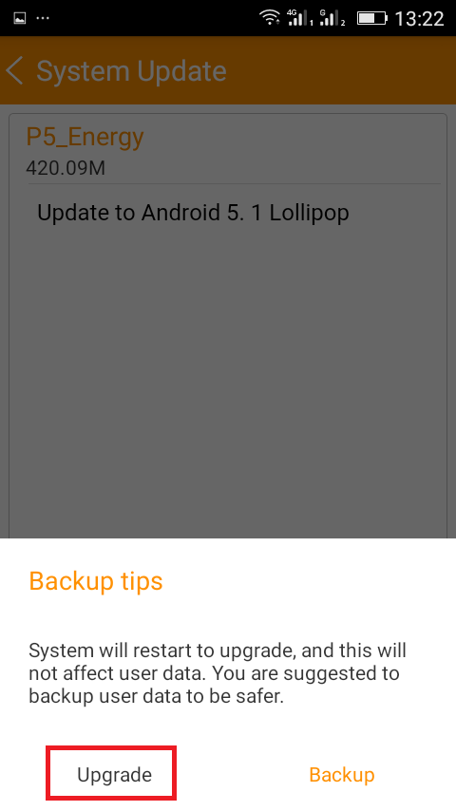

- The phone will reboot and the update procedure will start automatically .

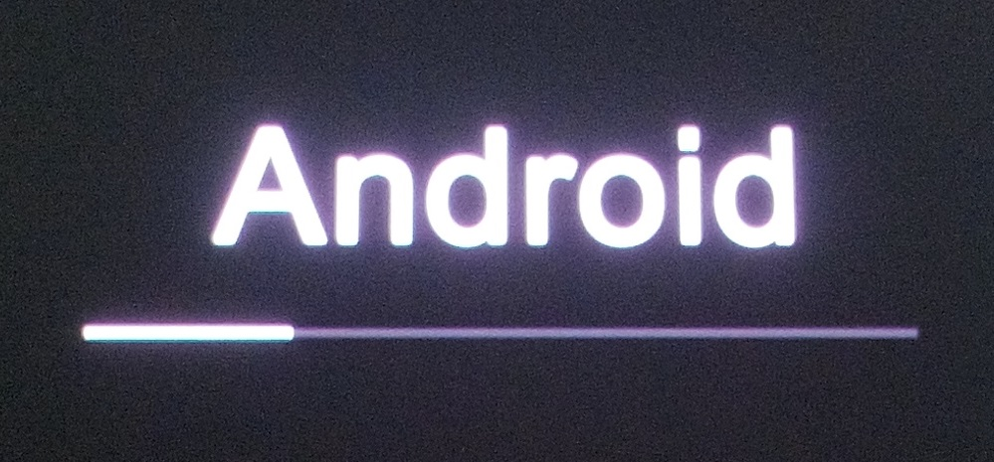

- After finishing the update process, the phone will reboot itself.

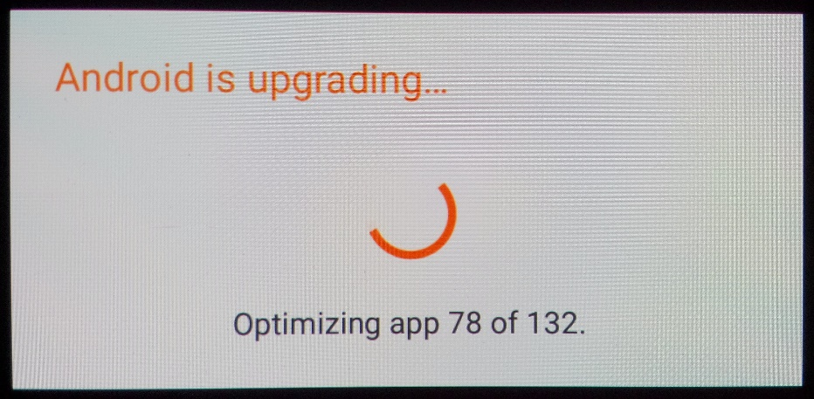

- On the phone's screen this message will be displayed: “Android is upgrading”.

The update file downloaded in the internal storage/microSD card will be deleted automatically after the termination of the update process.

